THE FINAL INTERNATIONAL RESEARCH AND PRACTICAL CONFERENCE
"Intercultural dialogue and collaboration of the European Union and Russia: Implementation of Jean Monnet Projects at Nizhnevartovsk State University"
Nizhnevartovsk State University, 15-19 April 2019

ACCOMODATION

Hotel Nadezhda
Address: 39, Severnaya Street
Type of room: Standard single room – 4000 rubles /night
Room size: 15 m²
Equipment: Private bathroom, TV, Telephone, Satellite channels, Desk, Heating, Wardrobe/Closet, Shower, Toilet, Slippers, Refrigerator, Towels, Linens
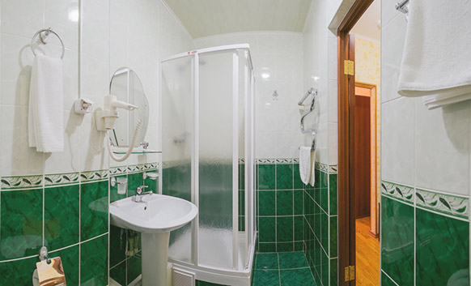
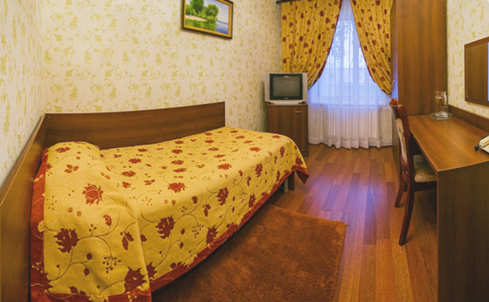

Type of room: Comfort single room – 5400 rubles /night
Room size: 16 m²
Equipment: Air – Conditioner, Private bathroom, TV, Telephone, Satellite channels, Desk, Heating, Wardrobe/Closet, Shower, Toilet, Slippers, Refrigerator, Towels, Linens
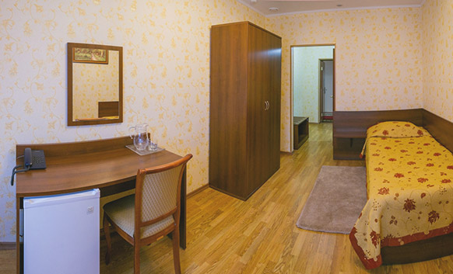

Type of room: Standard twin room – 5400 rubles /night
Room size: 19 m²

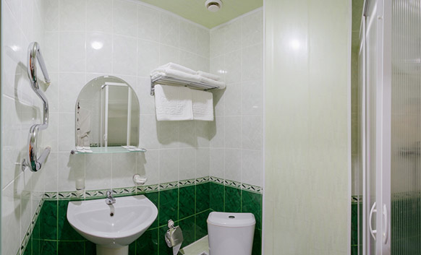
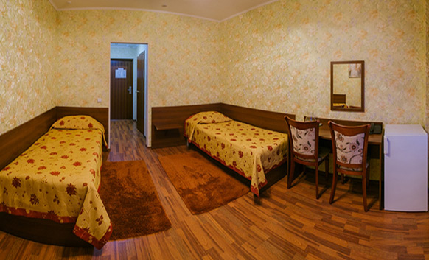

Equipment: Private bathroom, 2 single beds, TV, Telephone , Satellite channels, Desk, Heating , Wardrobe/Closet ,Shower, Toilet, Slippers, Refrigerator, Towels, Linens
Conditions: Breakfast, Wi-Fi, VAT included
Click for detailed information: www.nv-nadezhda.ru

